Generative AI Models

Index

S No | Topic | Page
1 | Models: GPT, DALL-E, Codex, Stable diffusion
2 | What's diffusion and GAN?
3 | What are transformers?
4 | Applications in enterprise AI

Models: GPT, DALL-E, Codex, Stable diffusion

GPT :
Generative Pre trained Transformer (GPT) is a language model that understands and generates human-like text. It learns patterns and relationships between words from large data and can perform multiple language tasks using a single model.

- Can read and understand human language.
- Generate meaningful and natural sounding text.
- Trained on large datasets to learn language patterns.
- Can write, summarize, answer questions and even help in coding.
- Understands how words relate to each other to give relevant responses.

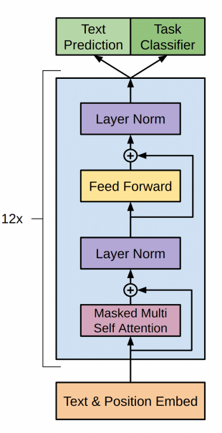
How GPT Works

GPT models are built upon the transformer architecture, introduced in 2017, which uses self attention mechanisms to process input data in parallel, allowing for efficient handling of long range dependencies in text. The core process involves:

- Pre-training: The model is trained on vast amounts of text data to learn language patterns, grammar, facts and some reasoning abilities.
- Fine-tuning: The pre-trained model is further trained on specific datasets with human feedback to align its responses with desired outputs.

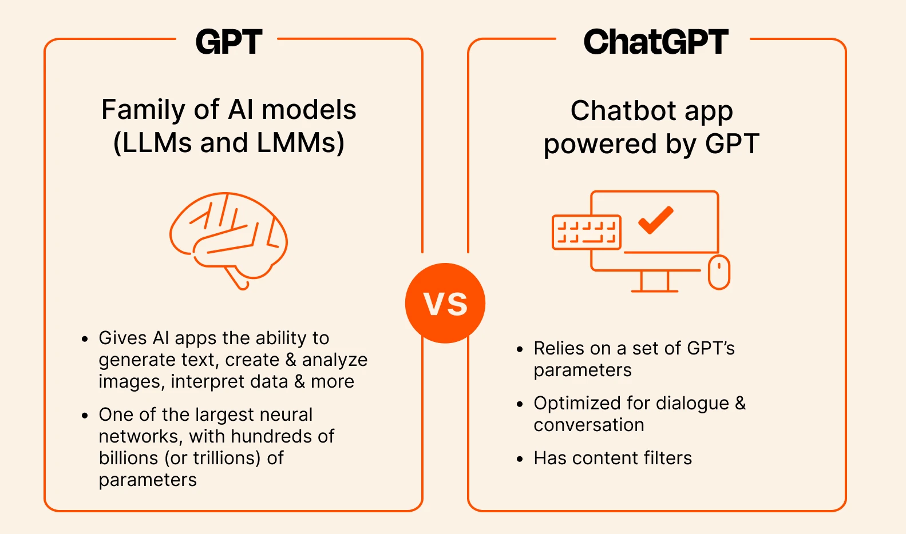
As you can imagine, GPT is used in a wide variety of different applications. The most well-known is ChatGPT, OpenAI's chatbot, which uses fine-tuned versions of GPT that are optimized for dialogue and conversation. Depending on what ChatGPT plan you're on, it will either default to the latest model or an earlier (but still competent model). ChatGPT Plus and Pro users will generally get access to better models sooner.

DALL-E:
DALL-E is a technology introduced by Open AI and it is a neural network-based picture-generating system. DALL-E is a technology that helps users create new images with their imagination only by using graphics prompts. DALL-E can create the impression that may look entirely different as mentioned by the user’s prompt. DALL-E is the variation of a model GPT 3(Generative Pre-trained Transformer )

DALL-E has made a greater impact due to its remarkable ability to create images that are highly realistic and real images just from textual description. At its core, DALE-E utilizes a modified version of the GPT-3 architecture. GPT-3, which primarily focuses on natural language processing, relies on the Transformer architecture, a neural network design known for its efficacy in handling sequences, be it sentences or time series data. This foundation is also what empowers DALE-E to understand and process textual descriptions efficiently.

How does DALL-E work?
DALL-E is a neural network and works on a transformer model. This model works on handling input data and making highly flexible data to run the various tasks of generative. Some of the applications of transformers are DALL-E which transforms the text into an image as per the need of the user.
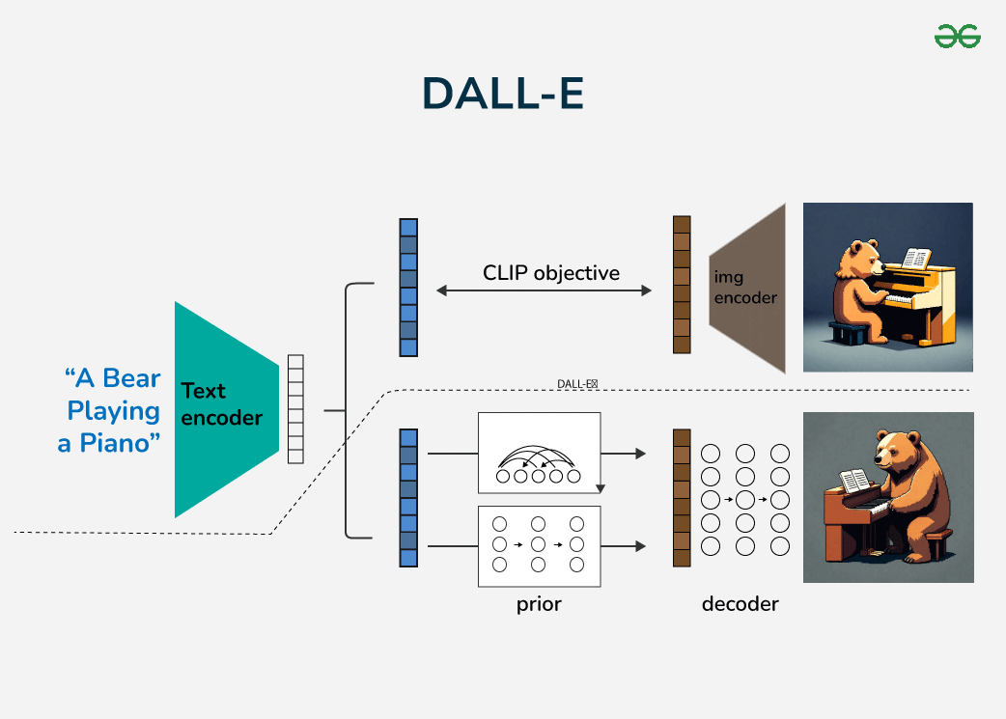

1. Training Phase: DALL-E is trained using vast datasets containing text-image pairs. The model learned the relationships between textual descriptions and images corresponding to that text.
2. Generating New Images: Once the model is trained with the data then DALL-E can take an input and predict the image that is corresponding to that. It does this by checking relationships it has learned and applying them to create a new input. The Main Mechanism behind DALL-E's Creativity is
- Latent space Interpolation: DALL-E operates on "latent space", a representation of data it was trained on. navigating and interpolating within the space, DALL E can blend concepts and produce an image.
- Attention Mechanism : The transformer architecture relies heavily on attention mechanisms, allowing the model to focus on specific parts of the input text when generating an image.
- Vast Training Data: The sheer volume and diversity of the training data equip DALL-E with a rich palette of concepts, enabling it to produce varied and often unexpected results.

Codex:
Codex is an AI-powered coding assistant developed by OpenAI. It helps developers in writing, understanding and maintaining code more efficiently. Unlike general-purpose AI chat tools, Codex is built specifically for software development and engineering workflows.

It is optimized for tasks such as writing functions, fixing bugs, refactoring code, generating tests and explaining complex logic. Codex understands programming intent and applies it in a structured way.

Codex works by analyzing both natural language instructions and the existing code context. This allows it to translate plain English into working code. It can also handle long-running engineering tasks that reflect real-world development practices. Developers can use Codex to build complete applications, improve legacy systems, automate workflows or quickly understand unfamiliar codebases.

The Benefits of Using Codex in Development Workflows

1. Context-Aware Code Generation
Codex can generate complete functions, classes and modules by understanding both natural language instructions and the surrounding codebase. It adapts to project structure, language conventions and existing logic. This makes the generated code more usable in real applications.

2. Step-by-Step Task Execution
One of Codex’s standout capabilities is its ability to work through tasks step by step. It can plan actions, execute them in sequence and adjust based on intermediate results. This is especially useful for multi-file changes, feature development and complex bug fixes.

3. Code Understanding and Explanation
Codex can analyze unfamiliar or legacy code and explain what it does in clear, simple terms. Developers can ask for line-by-line explanations, high-level summaries or logic breakdowns. It makes it easier to onboard new team members or understand large codebases.

4. Refactoring and Code Improvement
Codex helps improve existing code by refactoring it for better readability, maintainability and performance. It can restructure functions, simplify logic, remove duplication and align code with best practices without changing the intended behavior.

5. Automated Test Generation
Writing tests is time-consuming, but Codex can automatically generate unit and integration tests based on existing code. This helps teams improve test coverage, catch bugs earlier and maintain more reliable software.

6. Bug Detection and Fixes
Codex can identify common bugs, logic errors and edge cases by analyzing code behavior. Developers can ask it to debug issues, suggest fixes or explain why a particular error is happening, reducing debugging time significantly.

7. Long-Running Engineering Workflows
Unlike simple AI assistants, Codex can handle long-running tasks such as migrating codebases, updating dependencies or implementing features across multiple files. These workflows more closely resemble how real development work is done.

8. Automation and Scripting
Codex is also effective for automating repetitive tasks. It can generate scripts for file processing, data transformation, build automation and deployment-related tasks. It helps developers save time on routine work.

Stable Diffusion :
Stable Diffusion is a technique used in generative artificial intelligence, particularly in the context of image generation. It's an extension of the diffusion probabilistic model, which is a generative model used for image generation tasks. The diffusion model essentially learns to generate images by iteratively demising a random noise input.

Stable Diffusion builds upon this by introducing stability mechanisms to improve training and sample quality. This stability is achieved through various means, such as regularization techniques, architectural modifications, or algorithmic improvements.

Understanding Stable Diffusion
The Stable Diffusion Model is a mathematical model used in physics and statistical mechanics to describe the process of diffusion in complex systems. Diffusion is the movement of particles or molecules from an area of higher concentration to an area of lower concentration, driven by random thermal motion.
In many systems, especially those with disorder or heterogeneity, standard diffusion models like Fick's laws may not adequately describe the behavior observed. The Stable Diffusion Model addresses this by considering scenarios where the underlying distribution of displacements of diffusing particles has heavy tails, meaning that rare, extreme events occur more frequently than would be predicted by a normal distribution.

The Stable Diffusion Model is based on stable distributions, which are a class of probability distributions characterized by heavy tails. These distributions are defined by four parameters: the stability index α, skewness β, scale parameter γ, and location parameter δ.

The Stable Diffusion Model is particularly useful for describing diffusion in systems where standard models fail, such as in porous media, biological systems, or financial markets. It has applications in various fields including physics, chemistry, biology, economics, and finance.

One of the key advantages of the Stable Diffusion Model is its ability to capture non-Gaussian behavior, making it more suitable for systems with complex dynamics or heterogeneity. However, analyzing data using this model can be challenging due to the complexity of stable distributions and the need for specialized statistical methods
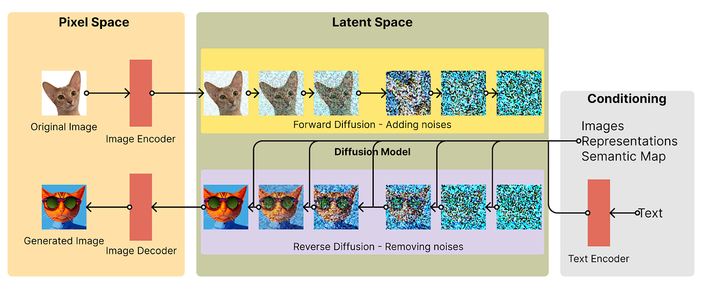

What's Diffusion and GAN?

Diffusion Models

Diffusion models are a type of generative AI that create data like images or audio by starting from random noise and gradually refining it into meaningful output. They learn this process by adding noise to real data during training and then reversing it step by step. This allows them to generate realistic and high-quality samples from scratch.

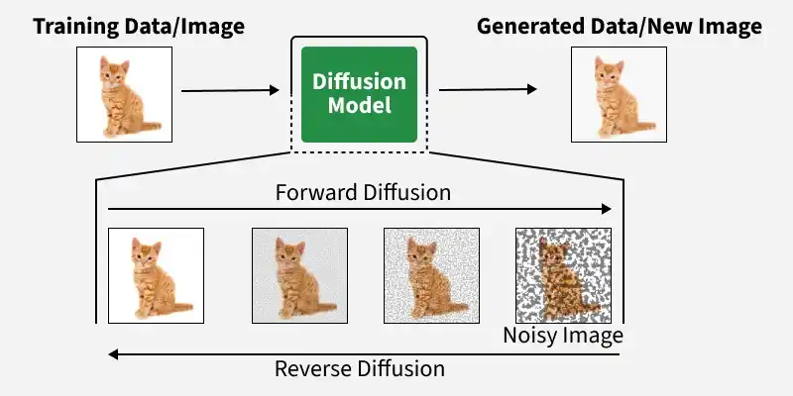

Diffusion models are generative models that create realistic data by learning to remove noise from random inputs.

During training, noise is gradually added to real data so the model learns how data degrades.
The model is trained to reverse this process by removing noise step-by-step.
This helps it learn complex data patterns and generate high-quality outputs.
At inference, it starts with random noise and gradually denoises it to produce data like images, audio or text.

Key Components
- Forward Diffusion Process (Noise Addition): A fixed, predefined process that gradually adds Gaussian noise to data over many timesteps, converting structured data into nearly pure noise.
- Reverse Diffusion Process (Denoising): A learnable process where a neural network (often a U-Net) predicts and removes noise step by step to reconstruct realistic data from noise.
- Score Function (Noise Estimation): Estimates the gradient of the data distribution (or directly predicts noise), guiding each denoising step toward more realistic samples.
- Time-Step Conditioning: The model is conditioned on the current timestep, allowing it to understand how much noise is present and how to remove it effectively at each stage.
- Sampling Strategy: New data is generated by starting from random noise and iteratively applying the learned reverse steps, often using techniques to improve speed and quality.

Generative Adversarial Network (GAN)

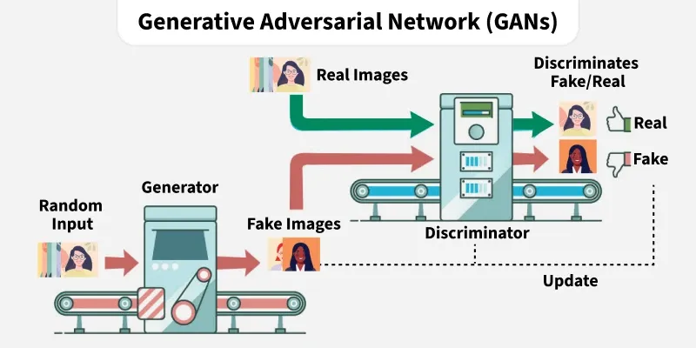

Generative Adversarial Networks, or GANs, represent a breakthrough in artificial intelligence by introducing a novel architecture that enables machines to generate new, synthetic instances of data that resemble real data. At their core, GANs involve two neural networks—the generator and the discriminator—that engage in a form of digital tug-of-war. This innovative structure allows GANs to produce remarkably realistic images, videos, and voice recordings, pushing the boundaries of AI’s creative capabilities.
They are useful because:
- Create new data similar to real world data
- Go beyond classification to generate content
- Used in art, gaming, healthcare and data science

Architecture of GAN
GAN consists of two neural networks, the generator and the discriminator trained adversarially, where the generator tries to fool the discriminator and the discriminator tries to distinguish real from fake data.
1. Generator Model
The generator is a deep neural network that takes random noise as input to generate realistic data samples like images or text. It learns the underlying data patterns by adjusting its internal parameters during training through backpropagation. Its objective is to produce samples that the discriminator classifies as real.
2. Discriminator Model
The discriminator is a binary classifier that distinguishes real data from generated samples. Through training, it refines its parameters to improve detection of fake data and when working with images, it uses convolutional layers to extract features and enhance classification accuracy.

What are transformers?

Transformer is a neural network architecture used for various machine learning tasks, especially in natural language processing and computer vision. It focuses on understanding relationships within data to process information more effectively.

Uses attention mechanisms to capture relationships between inputs
Processes entire sequences at once instead of step by step
Improves performance on tasks involving context and dependencies
Widely used across NLP, vision and other AI applications

Key Components of the Transformer Model
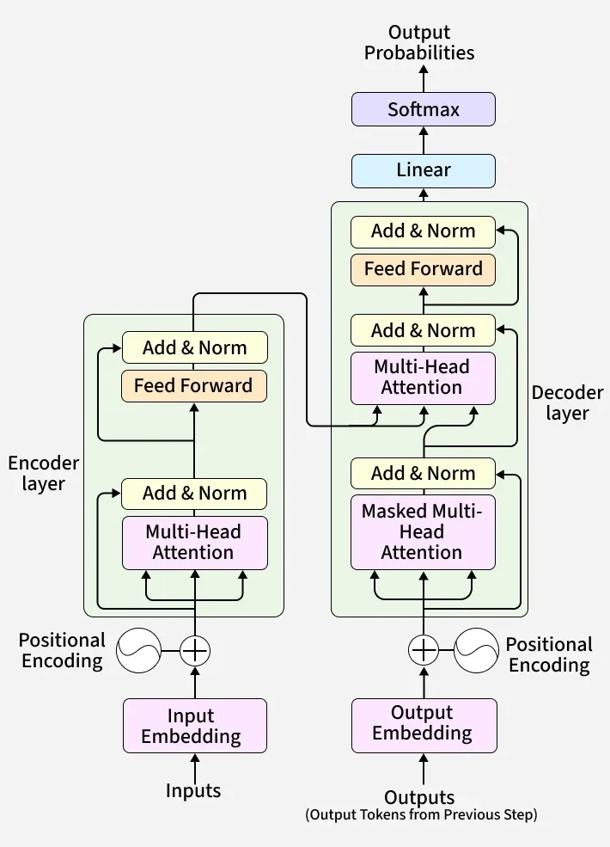

This section presents a brief overview of the key components that make the Transformer Model so successful −

Self-Attention Mechanism
The self-attention mechanism allows models to weigh different parts of the input sequence differently. It enables the model to capture long-range dependencies and relationships within the text, leading to more coherent and context-aware text generation.

Multi-Head Attention
The Transformer model uses multiple attention heads where each head operates independently and captures various aspects of the input data. To get the result, the outputs of these heads are combined. With the use of multi-head attention, transformers provide better representation of the input data.

Positional Encoding
Transformers cannot inherently capture the sequential nature of text that's why positional encoding is added to the input embeddings. The role of positional encoding is to provide information about the position of each word in the sequence.

Feedforward Neural Networks
After applying the self-attention mechanism, the transformed input representations are passed through feedforward neural networks (FFNN) for further processing.

Layer Normalization
Layer normalization allows the model to converge more efficiently because it helps stabilize and accelerate the training process.

Encoder-Decoder Structure
The Transformer model is composed of an encoder and a decoder, each consisting of multiple layers. The encoder processes the input sequence and generates an encoded representation, while the decoder uses this representation to generate the output sequence.

Applications in enterprise AI

1. Generative AI in Healthcare
Generative AI is improving healthcare and pharmaceuticals by drug discovery, personalized medicine and medical imaging. Below are some key applications of Generative AI in healthcare.
- Personalized treatment plans: Generative AI analysis of patient data brings customized treatment plans, increasing successful outcomes for patients. For example, there are companies using AI to make treatments specifically tailored for certain patients based on their particular genetic profiles.
- Synthetic Data Generation: Tools such as Insilico Medicine use generative AI to generate synthetic patient data for training machine learning models without violating privacy. For example: Insilico Medicine, Mayo Clinic.
- Early Detection of Diseases: Apps such as SkinVision use generative AI to analyze images of the skin to detect early signs of skin cancer and help in diagnosis.
2. Generative AI in Finance
Generative AI is transforming the finance industry by assisting with fraud detection, creating customized investment plans, and improving risk management. Below are some few simple examples:

- Feature space: It applies generative AI for creating seemingly real fake data on transactions. This prevents fraud more effectively and hence banks and payment companies, like PayPal, reduce loss.
- American Express: This company applies generative AI to watch over the pattern of spending on the credit card so that fraud will be detected before it strikes.
- JPMorgan Chase : They make use of generative AI to analyze risk when granting loans or making investments; they are, therefore, able to identify the potential flaws before they take place.
3. Generative AI in Entertainment and Media
Generative AI is revolutionizing the entertainment and media industry by making content creation faster, easier, and more efficient; video game development more streamlined; and even generating music. Below are some key applications with real-world examples:

- Canva: Canva has AI-powered features that make graphic design much simpler. Users can create great visuals, automatically resize images, and even generate designs from text-to-image, so that anyone can easily create professional-looking content.
- Unity ML-Agents: This technology enables game developers to make more intelligent NPCs that can learn the behavior of the players. For example, an NPC may change strategies depending on how the players play them, making the game far more interesting and realistic.
- MusicFy: Users can compose music with AI-generated voices and melodies on this platform. They input their ideas or select styles, and the AI produces complete songs, making it fun and easy to compose music.
4. Generative AI in Cyber Security
Generative AI is revolutionizing cybersecurity by improving threat detection and automating incident response. Generative AI is reshaping cybersecurity by proactively identifying threats, simulating attack scenarios, and enhancing incident response capabilities. Below are some few applications of Generative AI in Cyber Security.

- Anomaly Detection: Generative AI analyzes large datasets to identify patterns of normal behavior within a network. For instance, it can detect unusual spikes in network traffic that may indicate a malware attack or unauthorized access.
- Phishing Detection: Advanced phishing attacks can be countered through generative AI by natural language processing (NLP), analyzing the content of emails and social media communications to look for slight anomalies of false activities.
- Incident Analysis and Prioritization: Generative AI can automatically analyze security incidents in real time, prioritize them based on severity, and allow the security team to respond accordingly.
5. Generative AI in Education
Education is much advanced with real-life examples provided as part of the curriculum. Below are some educational topics with real-life examples.

- Mathematics: Teaching fractions by teaching children to cook. While in a recipe, they learn about measurements, which teaches how fractions work in real life.
- Science: Environmental science classes that include local water quality testing. Students collect and analyze water samples from rivers or lakes close to them to understand pollution and its effects on ecosystems.
- Literature: Issues in modern society through literature. The students read current novels with issues related to present society, which they relate and discuss in terms of themes from the literature that happen in real life.

6. Generative AI in Gaming
Games can use generative AI to create adaptive stories or environments that change and evolve based on the interaction of the player, offering them a unique experience each.

- Pokémon Go: This is a highly addictive mobile game where people take pictures of virtual Pokémon's in real-world locations and prompt them to be more physical and explore their surroundings.
- Duolingo : It is a language-learning application that integrates game elements into the experience, including badges, levels, and leader boards, to encourage people as well as make learning experience more enjoyable.
- Fitbit: This app gamifies fitness by allowing users to set goals, track their activity, and compete in challenges with friends, promoting healthier lifestyles through friendly competition.
7. Generative AI in Virtual Assistants
AI-powered chatbots use generative models to provide a more human-like interaction with customers in customer service scenarios, answering queries and resolving issues effectively.

- Erica (Bank of America): Erica is a virtual financial assistant that assists over 25 million users in managing their accounts, paying bills, and getting spending insights, making banking more accessible and efficient.
- Amazon Alexa: Alexa provides personalized product recommendations based on user preferences and past purchases, making shopping easier for millions of customers.
- Duolingo's AI Tutor: Duolingo employs a virtual assistant to tailor language lessons to the user's progress. It provides real-time feedback and gamified learning experiences.

